**How To Fix "The specified module could not be found" Error In Windows 10**

o open Registry Editor, right-click the Start button and select "Run" from the contextual menu. Type "regedit" and press Enter or click "OK

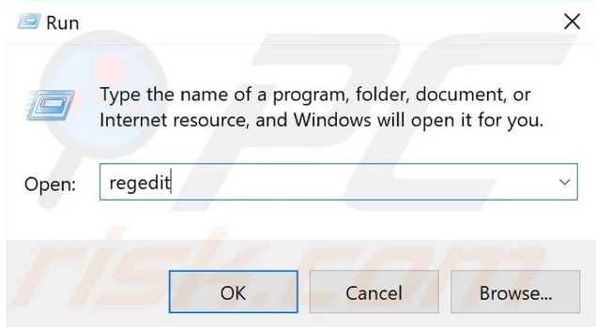

Now follow these paths and delete the entries by right-clicking on each and selecting "Delete" from the contextual menu:

HKEY_LOCAL_MACHINE\Software\Microsoft\Windows\CurrentVersion\Run  
HKEY_CURRENT_USER\Software\Microsoft\Windows\CurrentVersion\Run  
HKEY_LOCAL_MACHINE\Software\Microsoft\Windows\CurrentVersion\RunOnce  
HKEY_CURRENT_USER\Software\Microsoft\Windows\CurrentVersion\RunOnce

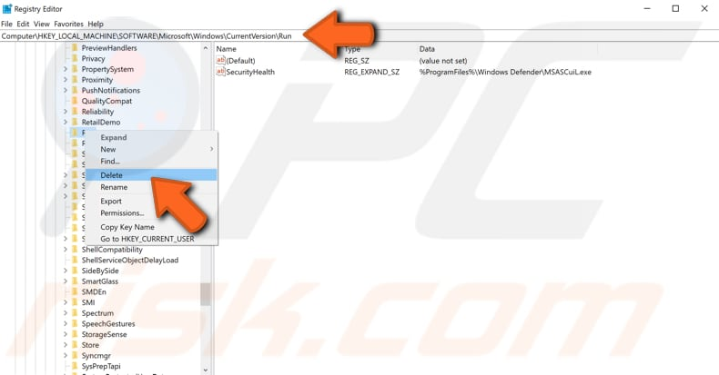

Restart the computer and see if this fixed the "The specified module could not be found" error.